**Proteomics: Module 4**

**Taniya Pal(s373094)**

**Introduction:**

To understand the function of a protein in a molecular level, we need information about three dimensional structure of protein. Three dimensional structures can b obtained through various wet lab techniques such as Nuclear Magnetic Resonance (NMR) or X-Ray Crystallography, also through computational techniques. The most successful computational technique for predicting a protein three dimensional structure is Homology Modelling (Launey et al). It follows the principle of that proteins having sequence identity should have similar structures. Regarding sequence identity, Launey et al specified a threshold of 35%, stating that proteins having sequence identity more than the threshold have “similar mode of interaction”.

SWISS-MODEL (<https://swissmodel.expasy.org>) is a protein homology modelling server which is being continuously improved from the last 25 years (Waterhouse et al). It uses a modelling engine called ProMod3 which builds a model on an atomic level using a template structure ( three dimensional structure of a homologous protein ) and target (the sequence of the protein whose structure is to be built) template sequence alignment. The workflow for modelling a SWISS protein model is as follows:

Input Data

(amino acid sequence in FASTA, CLUSTAL or plain text format)

Template Search

(Search for protein structures that are homologous using database searching tools such as BLAST or HHblits)

Template Selection

Model Building

Model Quality Estimation

The given sequence LPPNTQINESPRAELSVTERTLEPPTQSPSPPPRLS

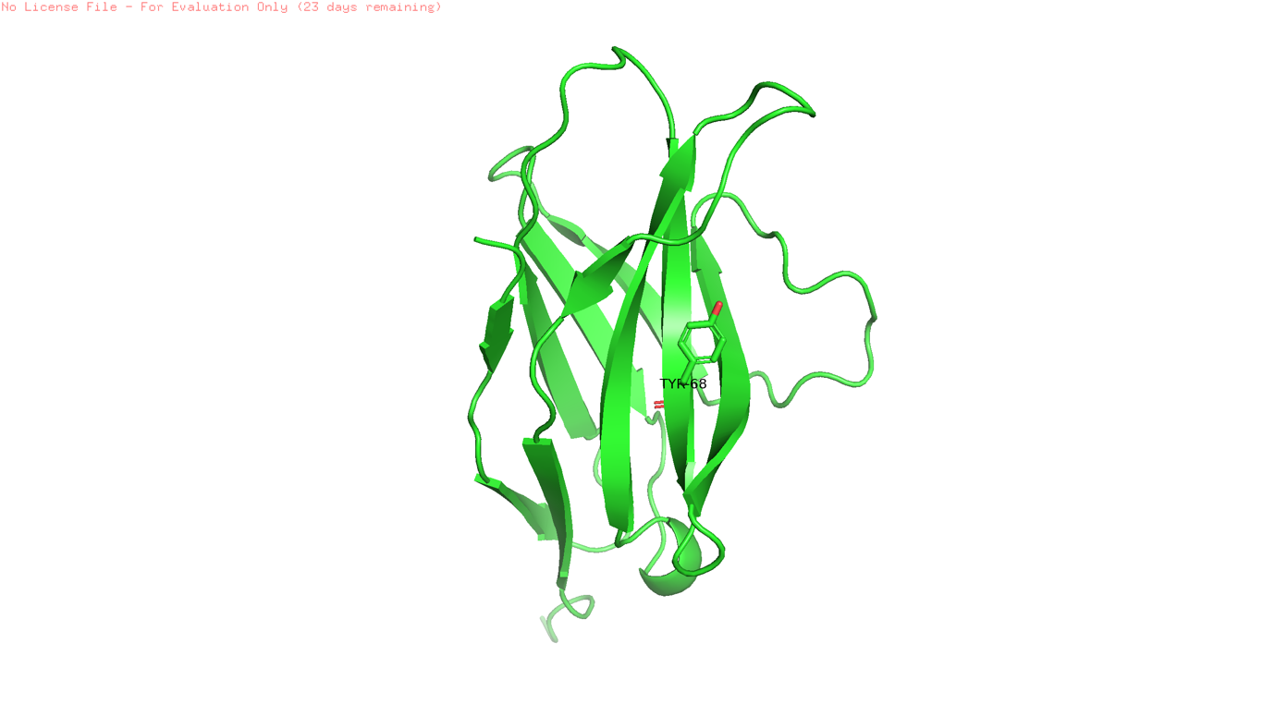was given as a query at BLAST in order to find which organism it belongs to. BLAST search with the database selected as “non redundant protein sequences” gave the organism as Canis lupus dingo. The sequence represents PD 1 protein (Programmed Cell Death Receptor) in Canis lupus Dingo. After getting the whole amino acid fasta sequence from UniProt for that organism, it was given as a query on BLAST, this time the database option selected as UniProt/SwissProt. Human PD 1 protein had the highest sequence identity with the query given in BLAST. The corresponding protein structure and fasta sequence was downloaded from PDB. The human PD1 protein fasta sequence was compared with the query FASTA sequence of Canis lupus dingo in a pairwise BLAST alignment. The sequence identity was above 35% so the SWISS homology model was developed with the same protein PDB structure. The target template was of Canis lupus dingo. After homology modelling, the protein was visualized as the following:

Immune cells are actively involved in regulating the expression of cancer specific antigens originating from cancer cells, but they are suppressed by various mechanisms. PD-I (Programmed death receptor-I) is involved in one of such mechanisms. It negatively regulates or exhausts the effector T cells which targets the antigens originating from cancer cells.

Cancer immunotherapy masks the inhibitory receptor PD-I or PD-I inhibitory receptor ligand (PD-L I) o tumor cells which have proved to drastically reduce cancer cells induced immunosuppression. Recent clinical trials have demonstrated the effectiveness of monoclonal antibodies in carrying out the same function.

Zak et al. has stated that Tyr 68 and LTyr 123 harbors Π-Π stacking interactions between their side chains optimizing dipole momentum. Thus Tyr 68 was highlighted in the modelled protein as it contributes to its binding interface.

References:

1. Waterhouse, A., Bertoni, M., Bienert, S., Studer, G., Tauriello, G., Gumienny, R., Heer, F.T., de Beer, T.A.P., Rempfer, C., Bordoli, L. and Lepore, R., 2018. SWISS-MODEL: homology modelling of protein structures and complexes. Nucleic acids research, 46(W1), pp.W296-W303.
2. Launay, G. and Simonson, T., 2008. Homology modelling of protein-protein complexes: a simple method and its possibilities and limitations. BMC bioinformatics, 9(1), pp.1-16.
3. Zak, K.M., Kitel, R., Przetocka, S., Golik, P., Guzik, K., Musielak, B., Dömling, A., Dubin, G. and Holak, T.A., 2015. Structure of the complex of human programmed death 1, PD-1, and its ligand PD-L1. Structure, 23(12), pp.2341-2348.